**Day 3 Assignment.**

1.Create a blank file named “myfile”

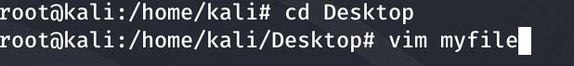

2.Open “myfile” in vi editor.

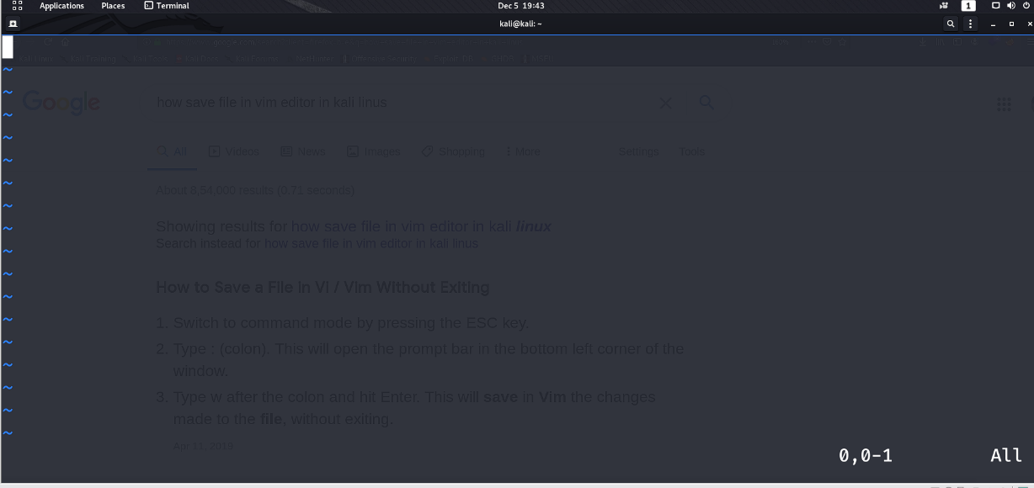

3.Write your name, address, email ID, phone number and blood group in 5 different lines.

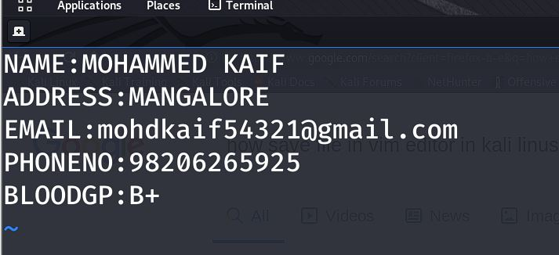

4.Build one single expression to see the lines with your name and blood group in myfile.

